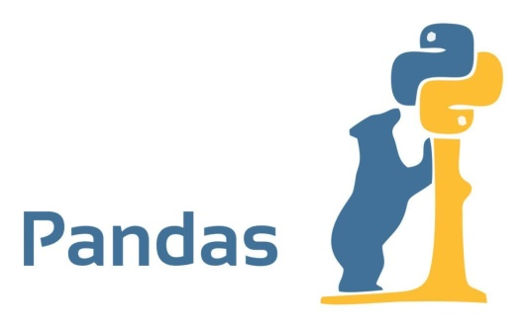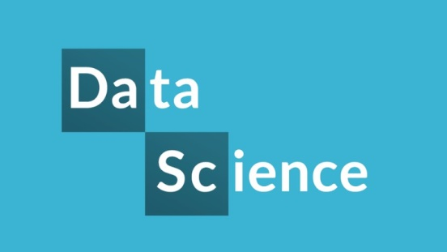

**Python**

**Data Analytics 101 with Python & Pandas**

An introductory workshop for data analysis/science with Python Pandas library taught by instructors.  
  
**What you’ll learn:**

* **Getting Started with Pandas**
  + **Data Structures**
  + **Function Applications**
  + **Descriptive Statistics**
* **Data Loading, Storage, and File Formats**
  + **Reading and Writing in Text Format**
  + **JSON, XML, HTML Format**
  + **Interacting with Web APIs, Databases**
* **Data Cleaning and Preparation**
  + **Missing Data**
  + **Data Transformation, Manipulation**
* **Data Wrangling: Join, Combine, and Reshape**
  + **Hierarchical Indexing**
  + **Combine, Reshape, Pivot Datasets**
* **Plotting and Visualization**
  + **Matplotlib, Pandas, and Seaborn**
  + **Line, Bar, Histogram, Scatter, FacetGrid plots**
* **Data Aggregation and Group Operations**
  + **GroupBy, Pivot Tables, Cross-Tabulations**